Self-Directed learning Activities 1
SAFEGUARDING ADULTS – LEVEL 2
26th September 2024
Task:
You are to complete learning and eAssessment on the e-learning for healthcare learning hub. The total time required to complete this is 35 minutes.
Please note that If you do not complete the eAssessment, you will not be issued the certificate indicating you have completed the learning.
Follow the instructions below to register to use the e-learning for healthcare hub.
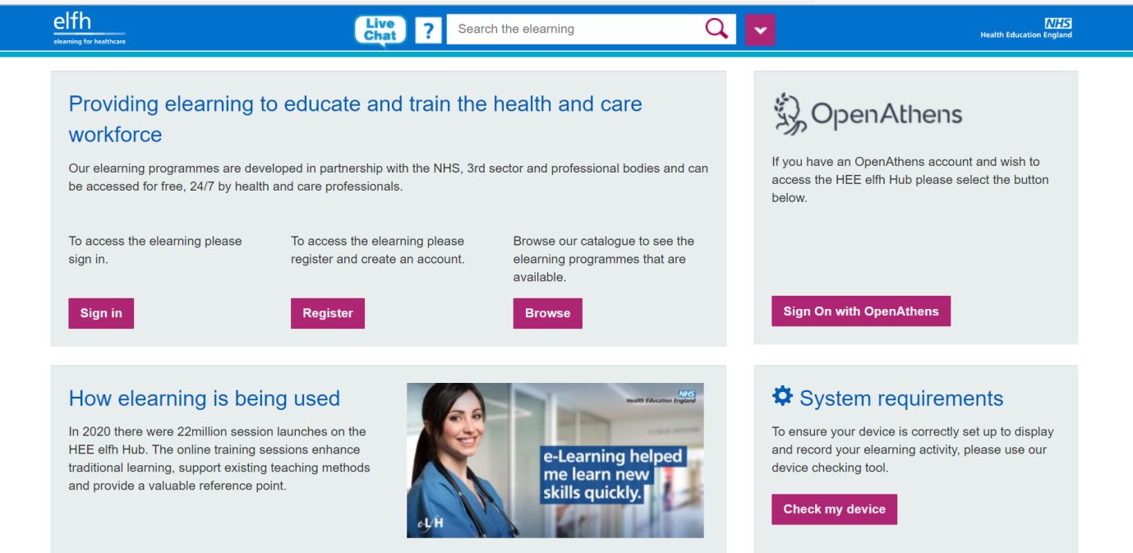
Figure 1 showing the login page of the HEE E- learning for health hub.
- Go to the portal at this link: https://portal.e-lfh.org.uk/
- Click the register button highlighted in Fig 1 above.
- You will need to use your London Met student email to register.
- After registering, you will be sent a unique login details and password for you.
You will need these details to access the self-directed tasks given during each week of the clinical simulation programme
After you have registered follow this link to the webpage for the self-directed learning today:
Safeguarding adults Level 2: https://portal.e-lfh.org.uk/Component/Details/577651
Learning Objectives
- List the principles of the Care Act (2014) which has changed the way people who have care and support needs, including those who are having difficulty understanding what is happening to them and should be assessed and involved in their care and support pathway
- Describe the importance of the safety and well-being of people with care and support needs, including making safeguarding personal and the identification of abuse and principles underlying the Care Act 2014 and Mental Capacity Act 2005 and subsequent MCA amendment ACT 2019
- Use your local multi-agency policies and procedures to identify the stages under the adult safeguarding process for the protection of adults with care and support needs
- Describe your local statutory adult safeguarding board's policy and procedures regarding escalation and challenge if you think that your concerns are not being taken seriously

At the end of the learning, download and save our Assessment score for your clinical portfolio.

